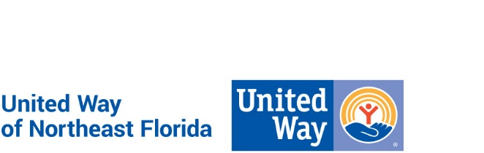

United Way of Northeast Florida
Position Description

Position Title: Junior Data Analyst

Department: Information Technology

Reports to: Melissa Dykes

Reviewed: March, 2021 FLSA Status: Intern/Seasonal

Vision and Mission:
At United Way of Northeast Florida, we envision a community of opportunity where everyone has hope and can reach their full potential. Our mission is to solve our community’s toughest challenges by connecting people, resources and ideas.

Diversity, Equity and Inclusion is not only valued and demonstrated in our hiring practices, it is a fundamental part of our mission throughout our organization and the communities we serve.

Purpose of Position:
The Junior Data Analyst will work closely with leaders and members of the Information Technology (IT) team to execute data analysis and maintenance. The incumbent will work with IT to execute scheduled data transformations and loads. He/She will communicate data insights that aid the organization in making business decisions and have the skills to balance multiple projects simultaneously.

Key Responsibilities and Essential Functions:
- Work with members of IT team to quickly learn data structure and processes
- Work with IT team members to assist in day to day Extract, Transform, Load operations
- Execute data maintenance and over see data clean up initiatives
- Process Documentation (Visio, Project, Planner, Teams, and Photoshop)

Experience/Position Requirements:
- Bachelors degree Computer Science, Computer Engineering, Software Engineering, Data Science or similar desired
- Critical thinking and analytical skills
- Passion to learn and solve problems
- Ability to learn quickly
- Ability to work collaboratively, act innovatively and embrace change
- Excellent verbal and written communication
- Ability to work in effectively in virtual and office environments
- Familiarity with SQL, especially MS SQL and SSMS
- Strong skills in MS Office
- Familiarity with Object Orientated Programming
- Familiarity with development and collaboration tools
- Familiar with Linux and Windows Operating Systems
- Ability to learn new tools, frameworks and languages
- Ability to work independently
- Advanced user of Excel, PowerPoint, and Word

Professional Core Competencies Required:
- Mission Focused: Creates real social change that leads to better lives and healthier communities. This drives performance and professional motivations.
- Relationship Oriented: Places people before process and is astute in cultivating and managing relationships toward a common goal.
- Collaborator (Includes teamwork and communication): Understands the roles and contributions of all sectors of the community and can mobilize resources (financial & human) through meaningful engagement. Strong supporter of a team environment.
- Results Driven: Dedicates efforts to shared and measurable goals for the common good; creating, resourcing, scaling and leveraging strategies and innovations for broad investment and impact.
- Brand Steward: Understands role in growing and protecting the reputation and results of the greater network.

General Physical Requirements for Essential Functions of the Job:
The physical demands described here represent those required to successfully perform the essential functions of this job. Reasonable accommodations may be allowed to enable individuals with disabilities to perform the essential functions. While performing the duties of this job the employee is regularly required to sit, talk, and/or hear. Continual use of the hands with wrist and finger movement using a keyboard is required. Specific vision abilities required by this job include long hours viewing a computer monitor screen. The employee may occasionally travel using personal vehicle and/or work outside normal office environment.

This description does not contain a comprehensive inventory of all responsibilities and qualifications required of all team members assigned to this position. It is intended to describe the key elements relative to each section. Duties and/or requirements of this position may be modified, added or deleted at any time. This supersedes all descriptions previously written for the same position. Unique equivalent skills and experience may possibly substitute for required position requirements.

United Way of Northeast Florida is an Equal Opportunity Employer and a Drug Free Work Environment.

