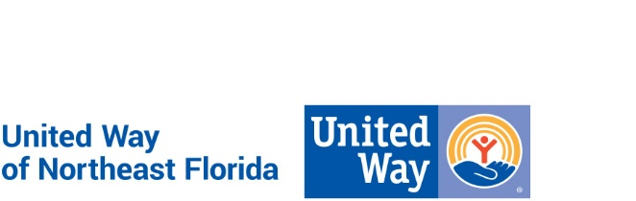

United Way of Northeast Florida
Position Description

Position Title: Intern

Department: Human Resources

Reports to: Vice President of Human Resources & Organizational Development

Reviewed: October 2019 FLSA Status: N/A

Vision and Mission:
At United Way of Northeast Florida, we envision a community of opportunity where everyone has hope and can reach their full potential. Our mission is to solve our community’s toughest challenges by connecting people, resources and ideas.

Diversity, Equity and Inclusion is not only valued and demonstrated in our hiring practices, it is a fundamental part of our mission throughout our organization and the communities we serve.

Purpose of Position:
United Way of Northeast Florida is seeking a personable and highly motivated HR intern to support the VP of HR and Organizational Development in day-to-day administrative tasks and activities.

If you’re ready to kickstart your career in Human Resources and build real-world experience with recruiting, training, employee development and the coordination of HR policies and procedures, this is the internship for you.

Key Responsibilities and Essential Functions:
- Post new positions on websites and job boards
- Assist with screening resumes and applications
- Send offer and regret letters
- Coordinate interviews
- Collect and update our database with new hire information (e.g. employment forms and contact information)
- Research and implement employee development activities; proofread HR documents
- Help prepare Word, PowerPoint, and Excel documents to track and monitor helpful data
- Track progress, priorities and deadlines of various projects

Experience / Position Requirements:
- Human Resources Management or Business major
- Some experience in an office environment preferred
- Experience with Microsoft Office Suite and resume databases
- Excellent interpersonal and communication skills
- Ability to work in a fast-paced, team-oriented environment
- Solid organizational skills and attention to detail

Benefits:
- Develop experience working on a wide variety of HR projects
- Gain exposure to a fast-paced, collaborative office environment
- Work side-by-side with a highly experienced HR executive
- Organize and attend company meetings and networking events

Professional Core Competencies Required:
- Mission Focused: Creates real social change that leads to better lives and healthier communities. This drives performance and professional motivations.
- Relationship Oriented: Places people before process and is astute in cultivating and managing relationships toward a common goal.
- Collaborator (Includes teamwork and communication): Understands the roles and contributions of all sectors of the community and can mobilize resources (financial & human) through meaningful engagement. Strong supporter of a team environment.
- Results Driven: Dedicates efforts to shared and measurable goals for the common good; creating, resourcing, scaling and leveraging strategies and innovations for broad investment and impact.
- Brand Steward: Understands role in growing and protecting the reputation and results of the greater network.

General Physical Requirements for Essential Functions of the Job:
The physical demands described here are representative of those that must be met by an employee to successfully perform the essential functions of this job. Reasonable accommodations may be made to enable individuals with disabilities to perform the essential functions. While performing the duties of this job the employee is regularly required to sit, talk, and/or hear. Continual use of the hands with wrist and finger movement using a keyboard is required. Specific vision abilities required by this job include long hours viewing a computer monitor screen. The employee may occasionally travel using personal vehicle and/or work outside normal office environment.

This description is not designed to contain a comprehensive inventory of all responsibilities and qualifications required of all team members assigned to this position. It is intended only to describe the key elements relative to each section. Also, duties and/or requirements of this position may be modified, added or deleted at any time. This supersedes all descriptions previously written for the same position. Unique equivalent skills and experience may possibly substitute for required position requirements.

United Way of Northeast Florida is an Equal Opportunity Employer and a Drug Free Work Environment.

Location:
Jessie Ball duPont Center
40 East Adams Street
Suite 200
Jacksonville, FL 32202

